1.1 Which statement about methods is true?
Select the one correct answer.

(a) A method is an implementation of an abstraction.
(b) A method is an attribute defining the property of a particular abstraction.
(c) A method is a category of objects.
(d) A method is an operation defining the behavior for a particular abstraction.
(e) A method is a blueprint for making operations.

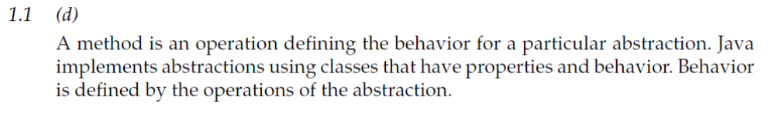

1.2 Which statement about objects is true?
Select the one correct answer.

(a) An object is what classes are instantiated from.
(b) An object is an instance of a class.
(c) An object is a blueprint for creating concrete realization of abstractions.
(d) An object is a reference.
(e) An object is a variable.

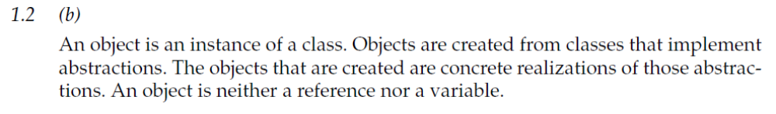

1.3 Which is the first line of a constructor declaration in the following code?

public class Counter { // (1)
int current, step;
public Counter(int startValue, int stepValue) { // (2)
setCurrent(startValue);
setStep(stepValue);
}
public int getCurrent() { return current; } // (3)
public void setCurrent(int value) { current = value; } // (4)
public void setStep(int stepValue) { step = stepValue; } // (5)
}

(a) (1)
(b) (2)
(c) (3)
(d) (4)
(e) (5)

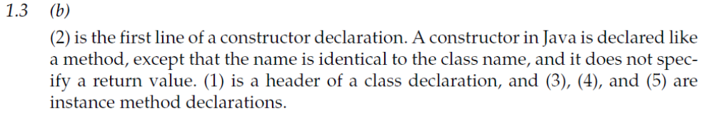

1.4 Given that Thing is a class, how many objects and how many reference variables are created by the following code?

Thing item, stuff;
item = new Thing();
Thing entity = new Thing();

Select the two correct answers.

(a) One object is created.
(b) Two objects are created.
(c) Three objects are created.
(d) One reference variable is created.
(e) Two reference variables are created.
(f) Three reference variables are created.

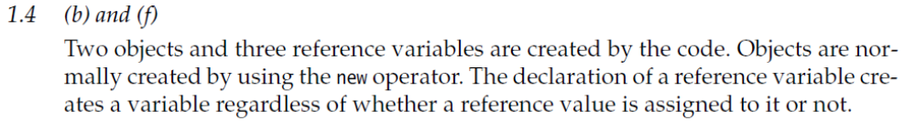

1.5 Which statement about instance members is true?
Select the one correct answer.

(a) An instance member is also called a static member.
(b) An instance member is always a field.
(c) An instance member is never a method.
(d) An instance member belongs to an instance, not to the class as a whole.
(e) An instance member always represents an operation.

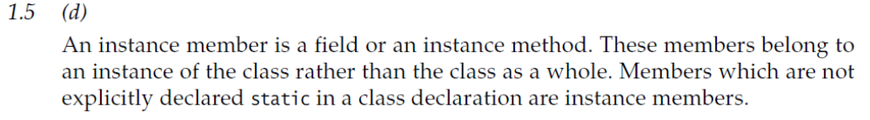

1.6 How do objects communicate in Java?
Select the one correct answer.

(a) They communicate by modifying each other’s fields.
(b) They communicate by modifying the static variables of each other’s classes.
(c) They communicate by calling each other’s instance methods.
(d) They communicate by calling static methods of each other’s classes.

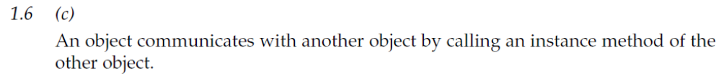

1.7 Given the following code, which statements are true?

class A {
int value1;
}

class B extends A {
int value2;
}

Select the two correct answers.

(a) Class A extends class B.
(b) Class B is the superclass of class A.
(c) Class A inherits from class B.
(d) Class B is a subclass of class A.
(e) Objects of class A have a field named value2.
(f) Objects of class B have a field named value1.

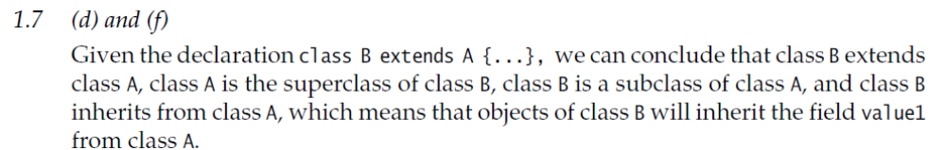

1.8 Which command from the JDK should be used to compile the following source
code contained in a file named SmallProg.java?

public class SmallProg {
public static void main(String[] args) {
System.out.println("Good luck!");
}
}

Select the one correct answer.
(a) java SmallProg
(b) javac SmallProg
(c) java SmallProg.java
(d) javac SmallProg.java
(e) java SmallProg main

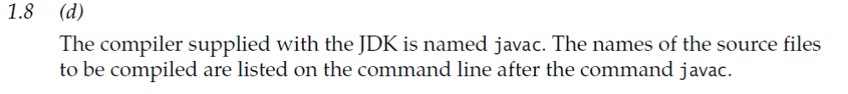

1.9 Which command from the JDK should be used to execute the main() method of a
class named SmallProg?
Select the one correct answer.

(a) java SmallProg
(b) javac SmallProg
(c) java SmallProg.java
(d) java SmallProg.class
(e) java SmallProg.main()

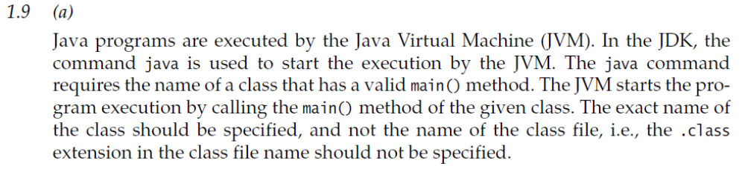

2.1 Which of the following is not a legal identifier?
Select the one correct answer.

(a) a2z
(b) цdipus
(c) 52pickup
(d) _class
(e) ca$h

2.2 Which statement is true?
Select the one correct answer.

(a) new and delete are keywords in the Java language.
(b) try, catch, and thrown are keywords in the Java language.
(c) static, unsigned, and long are keywords in the Java language.
(d) exit, class, and while are keywords in the Java language.
(e) return, goto, and default are keywords in the Java language.
(f) for, while, and next are keywords in the Java language.

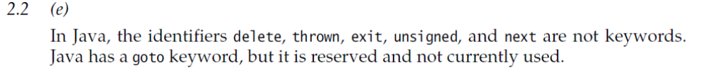

2.3 Which statement about the following comment is true?
/* // */
Select the one correct answer.

(a) The comment is not valid. The multiple-line comment (/* ... */) does not
end correctly, since the comment-end sequence */ is a part of the single-line
comment (// ...).
(b) It is a completely valid comment. The // part is ignored by the compiler.
(c) This combination of comments is illegal, and will result in a compile
time error.

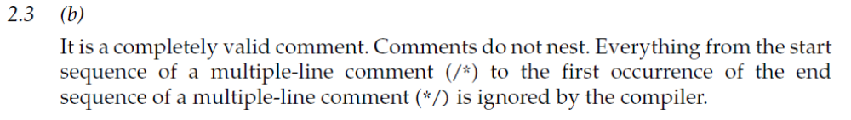

2.4 Which of the following do not denote a primitive data value in Java?
Select the two correct answers.

(a) "t"
(b) 'k'
(c) 50.5F
(d) "hello"
(e) false

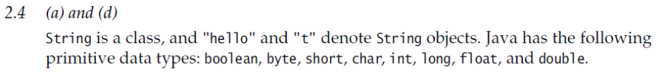

2.5 Which of the following primitive data types are not integer types?
Select the three correct answers.

(a) boolean
(b) byte
(c) float
(d) short
(e) double

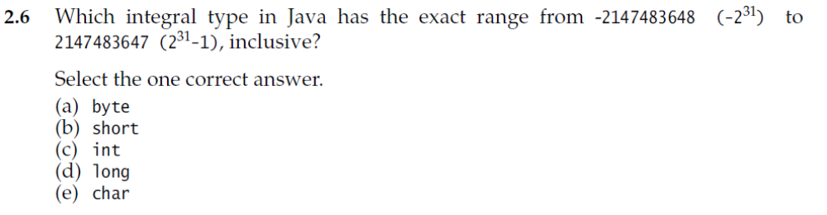

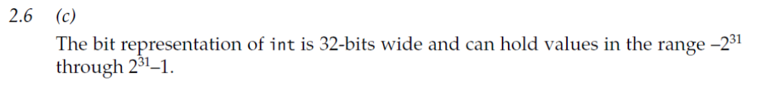

2.7 Which declarations are valid?
Select the three correct answers.

(a) char a = '\u0061';
(b) char 'a' = 'a';
(c) char \u0061 = 'a';
(d) ch\u0061r a = 'a';
(e) ch'a'r a = 'a';

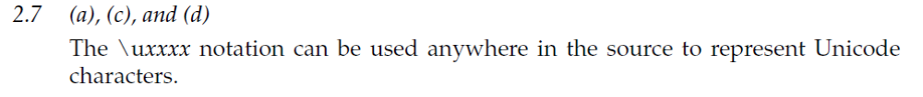

2.8 Given the following code within a method, which statement is true?

int a, b;
b = 5;

Select the one correct answer.
(a) Local variable a is not declared.
(b) Local variable b is not declared.
(c) Local variable a is declared but not initialized.
(d) Local variable b is declared but not initialized.
(e) Local variable b is initialized but not declared.

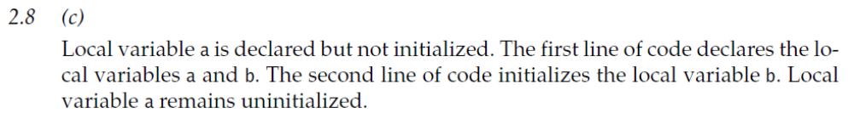

2.9 In which of these variable declarations will the variable remain uninitialized
unless it is explicitly initialized?
Select the one correct answer.

(a) Declaration of an instance variable of type int.
(b) Declaration of a static variable of type float.
(c) Declaration of a local variable of type float.
(d) Declaration of a static variable of type Object.
(e) Declaration of an instance variable of type int[].

